Periodicity Data Analysis: Trends and Discontinuities

Purpose:
- Determine Periodic Trends
- Explain Discontinuities using knowledge of atomic structure and interactions

Definitions:

Period: a horizontal row of the table
What does the period number tell you?

Group / Family: a vertical column of the table
What does the group number tell you?

Periodic law: properties repeat (happen periodically) if you arrange elements in order of increasing atomic number (Z)

Before you begin, define the following terms:

Atomic radius –

Ionization Energy –

Electron Affinity –

Electronegativity –

Effective nuclear charge –

Isoelectronic –

Ionization Energy vs. Z (eV*)
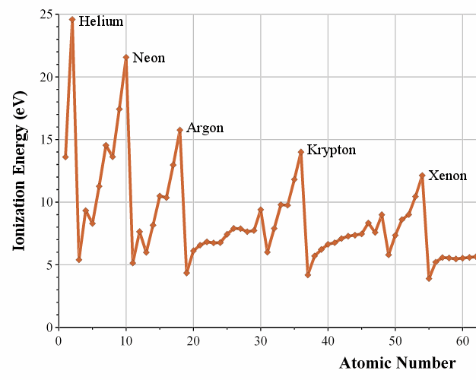
*The electron volt (symbol eV; also written electronvolt)
is a unit of energy approximately equal to 1.602×10⁻¹⁹ J.
Atomic Radius vs. Z
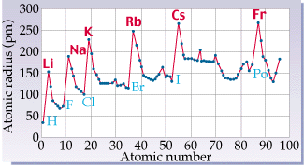

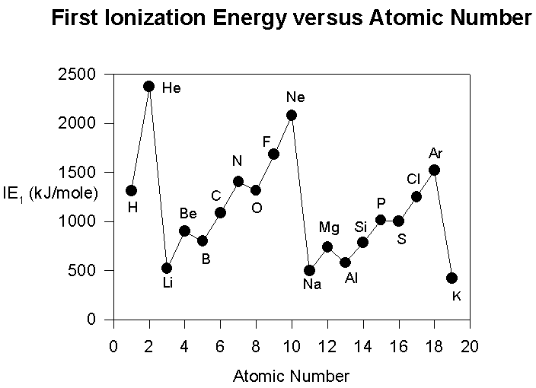

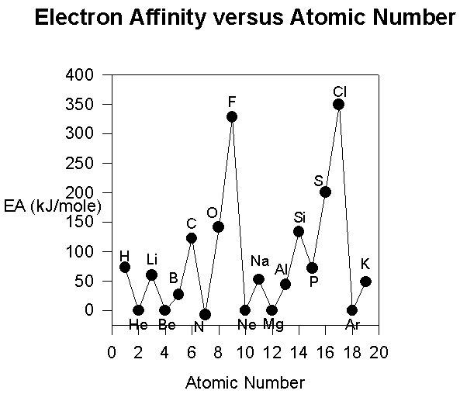

Graph Analysis Questions
Using the graphs provided, your Periodic Table, and your knowledge of atomic structure, answer the following analysis questions on a separate sheet of paper and attach.

- Use the details of modern atomic theory to explain each of the following experimental observations.

- Within a family such as the alkali metals, the ionic radius increases as the atomic number increases.

(b) The radius of the chlorine atom is smaller than the radius of the chloride ion, Cl⁻.
(Radii: Cl atom = 0.99Å; Cl⁻ ion = 1.81Å)

(c) For magnesium, the difference between the second and third ionization energies is much larger than
the difference between the first and second ionization energies. Ionization energies for Mg:
1st = 7.6 eV 2nd = 14 eV 3rd = 80 eV

2. Using the Ionization Energy (kJ mol⁻¹) graph as a reference, briefly (in one to three sentences) explain each of the following in terms of atomic structure.

(a) In general, there is an increase in the first ionization energy from Li to Ne.

- The first ionization energy of B is lower than that of Be.

- The first ionization energy of O is lower than that of N.

- Predict how the first ionization energy of Na compares to those of Li and of Ne. Explain.

3. Account for each of the following in terms of principles of atom structure, including the number, properties, and arrangements of subatomic particles.

(a) The second ionization energy of sodium is about three times greater than the second ionization energy of magnesium.

(b) The difference between the atomic radii of Na and K is relatively large compared to the difference between the atomic radii of Rb and Cs.

(c) A sample of nickel chloride is attracted to a magnetic field, whereas a sample of solid zinc chloride is not.

4. Use principles of atomic structure to answer each of the following.

(a) The radius of the Ca atom is 0.197 nanometer; the radius of the Ca²⁺ ion is 0.099 nanometer.
Account for this difference.

(b) The first and second ionization energies of K are 419 kJ/mol and 3052 kJ/mol, and those of Ca are 590 kJ/mol and 1145 kJ/mol, respectively. Account for the observed differences in their

(i) first ionization energies

(ii) second ionization energies

(c) The first ionization energy of Mg is 738 kJ mol⁻¹ and that of Al is 578 kJ mol⁻¹. Account for this difference.

5. Explain each of the following observations using principles of atomic structure and/or bonding.

(a) Potassium has a lower first ionization energy than lithium.

(b) The ionic radius of N^{3–} is larger than that of O^{2–}.

(c) A calcium atom is larger than a zinc atom.

- The first ionization energy of S is less than that of P.

6. The electron affinities of five elements are given below:

Boron: 26.7 kJ/mol
Carbon: 153.9 kJ/mol
Nitrogen: 7 kJ/mol
Oxygen: 141 kJ/mol
Fluorine: 328 kJ/mol

For the elements above, explain the observed trend as atomic number increases. Account for the break in this trend at nitrogen.

